Lab Activity 09 Worksheet

Place your screenshots and / or answers to questions here.

Each Part is 1 point, for a total of 10 points.

# Part 1 Screen Shot showing that a 2GB virtual hard drive was added to your virtual machine.

# Part 2 Screen Shot of 2GB disk with partitions set up as specified.

# Part 3 Screen Shot of formatting each partition with mkfs to apply Ext4.

# Part 4 Screen Shot of verifying each partitions file system.

# Part 5 Screen Shot of creating a mount-point folder.

# Part 6 Screen Shot of mounting one hard drive.



# Part 7 Screen Shot of changing permissions on one hard drive.

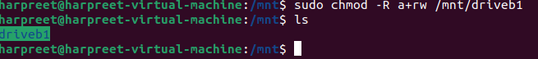

# Part 8 Screen Shot of writing and reading text to a mounted hard drive.

# Part 9 Screen Shot of deleting a text file from a mounted hard drive.

# Part 10 Screen Shot of unmounting a hard drive.

